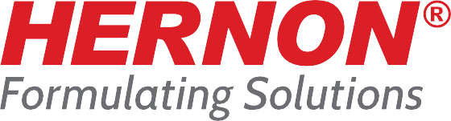

# FOR IMMEDIATE RELEASE CONTACT:

Alisande Morales: Marketing Manager [alisandemorales*@*hernon.com](mailto:alisandemorales@hernon.com)

Hernon Manufacturing, Inc.® 121 Tech Drive, Sanford FL 32771

407-322-4000

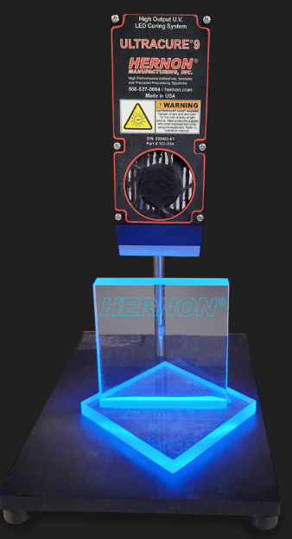hernon.com

**Hernon® Develops Breakthrough UV Curable Adhesive for Versatile Plastic Sealing**

**SANFORD, FL - June 2023 -** Hernon Manufacturing, Inc.® is proud to unveil Hernon Ultrabond Sealant 721, a cutting-edge UV curable adhesive designed to deliver exceptional sealing capabilities for a wide range of plastics. This revolutionary sealant forms a water-tight bond with excellent environmental resistance, ensuring optimal performance in various applications.

One of the standout features of Ultrabond Sealant 721 is its ability to prevent material from escaping through a crimped seal. This not only ensures a secure seal but also enhances the overall integrity of the assembly. By utilizing a low powered UV lamp (Blacklight), users can easily inspect the presence of adhesive on the substrates, enabling efficient and precise quality control during the manufacturing process.

"Hernon Ultrabond Sealant 721 represents a significant advancement in UV curable adhesives," said Seda Borak, Lab Manager at Hernon. "With its superior sealing properties, water resistance, and excellent adhesion to plastics, this sealant opens up new possibilities for various industries, including automotive, electronics, and medical devices. We are proud to offer a solution that not only provides outstanding performance but also prioritizes safety and environmental sustainability."

Hernon Ultrabond Sealant 721 is now available for purchase, enabling manufacturers to optimize their sealing processes with confidence. For more information, please visit [www.hernon.com](http://www.hernon.com/).

# About Hernon®

Hernon Manufacturing, Inc.® produces high-performance adhesives, sealants, UV LED curing lights and precision dispensing systems. Hernon® maintains a library unique adhesive and sealant formulas in addition to creating customized formulas to address specific manufacturing challenges. A full in-house chemical laboratory ensures quick turn around on testing and development projects and an on-site equipment division allows Hernon® to build, service and integrate unique dispensing systems to even the most exacting specifications. This integration helps Hernon® to provide customers with a Total Solution for any unique application.